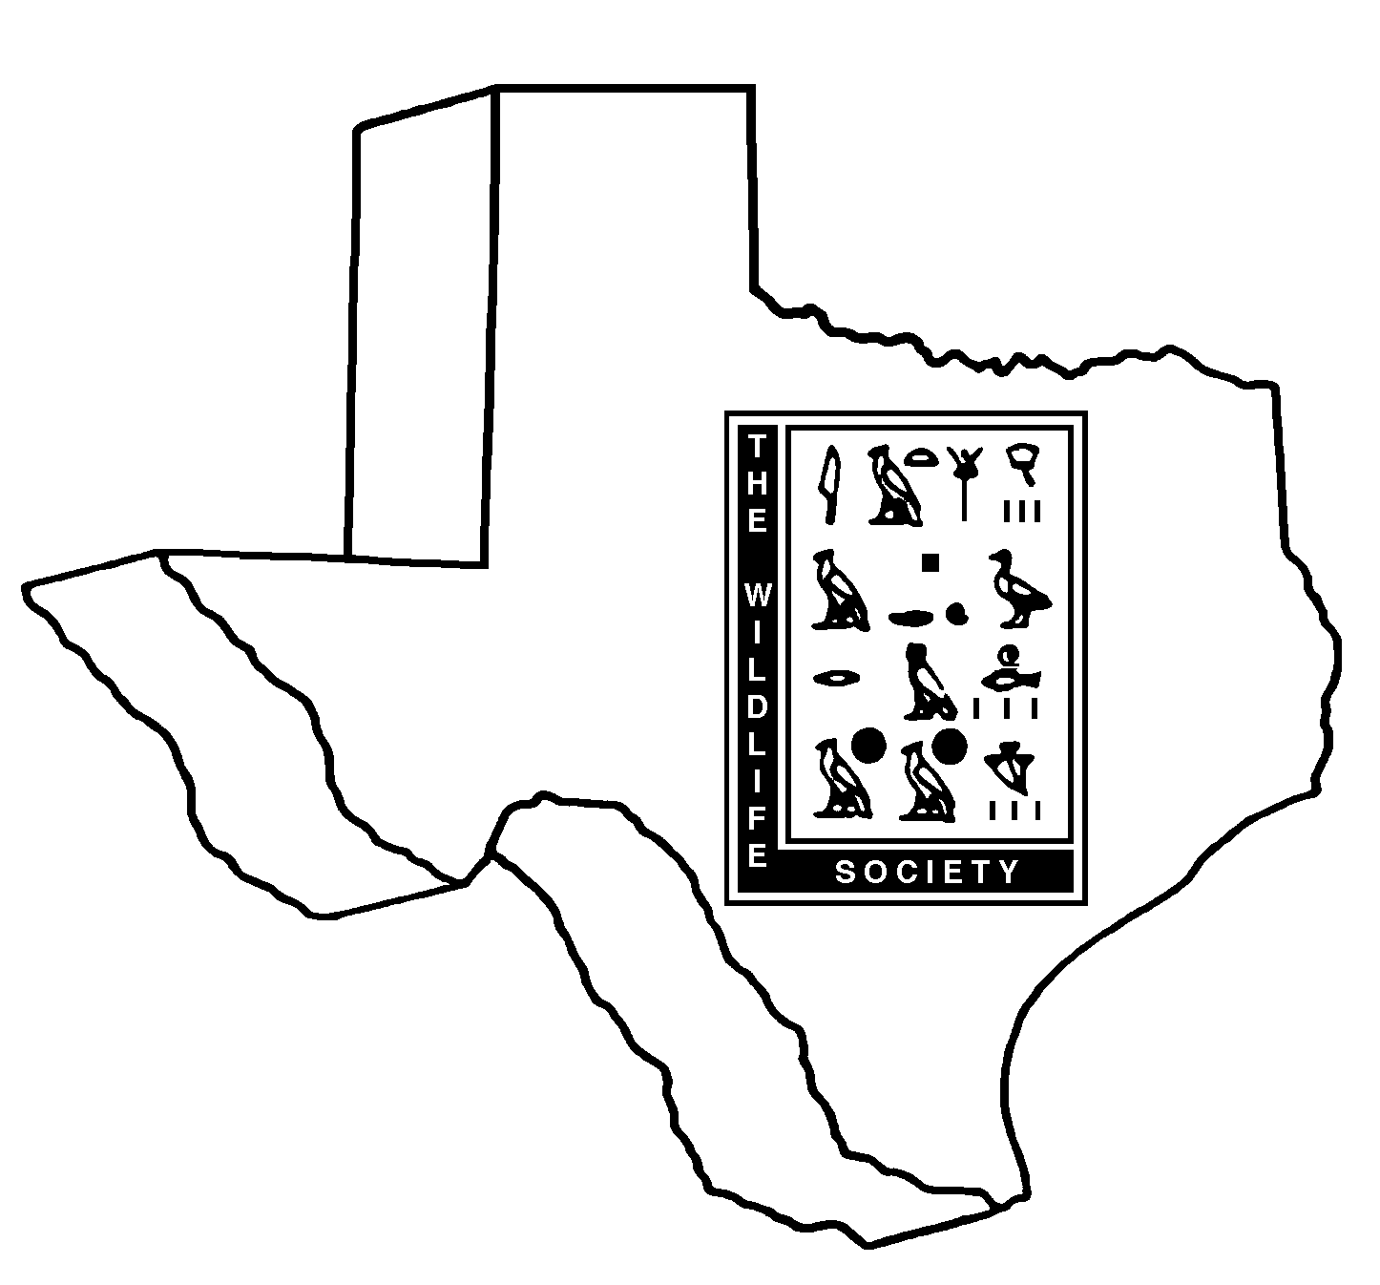

TEXAS CHAPTER
THE WILDLIFE SOCIETY

GRADUATE ASSISTANCE GRANT APPLICATION

SECTION A. (Please type application.)

1. Last Name: First Name: MI:

2. Mailing Address: City: State/Zip:

3. Hometown:

4. Email address(es):

5. Completion date of M.S., M.Ag, or Ph.D requirements and/or graduation date:

6. College grade point average (GPA) on a 4-point scale:

7. Please send an image of yourself in the event that you are selected to receive a scholarship; this photograph may be used at the awards banquet.

SECTION B. (Please use as much space as necessary.)

List professional and scientific organizations/activities in which you have been involved and length of involvement. Describe your level of involvement with the Texas Chapter of the Wildlife Society and include any offices you have held or committees served on.

List fellowships, scholarships, and awards that you have received.

List technical and non-technical publications that you have authored or co-authored, and/or symposia at which you have presented.

List work experience, volunteer positions and/or internships that you have held since beginning college-level studies (please limit to natural resource related fields).

Estimate the percentage of graduate level educational expenses currently not provided through research stipends: _____________.

Describe your long-term goals and reasons for pursuing a graduate level degree in natural resource conservation.

ESSAY QUESTION(S): A currently debated issue is the ownership and transfer of public lands in the western U.S. The federal government owns approximately 47% of the land in the western states. What are some pros and cons of holding this much land? What are other reasonable strategies that would benefit citizens of the U.S. and the western states? What importance does public land have to you?

SECTION C: (Please attach the following after the application and convert all materials to pdf.)
- Graduate research proposal synopsis (≤300 words), 2) letter of recommendation, and 3) copy of college transcript(s).

PARTICIPATION AGREEMENT

I, , hereby declare my intention to participate in the Texas Chapter of the Wildlife Society as a volunteer in a chapter function or provide coaching, mentoring or training to other students within 12 months of obtaining this scholarship.

Signature: Date:

Faculty Advisor Signature: ______________________________ Date:
Faculty Advisor Printed Name:_______________________________________________

