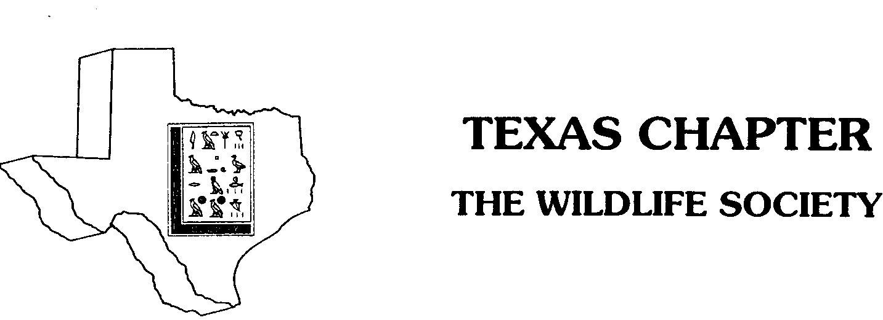

UNDERGRADUATE SCHOLARSHIP APPLICATION

SECTION A. (Please type application.)

- Last Name: First Name: MI:

- Mailing Address: City: State/Zip:

- Email Address(es):

- Hometown:

5. Classification (Please Circle): Sophomore Junior Senior

6. Completion of B.S. requirements or graduation date:

7. College grade point average (GPA) on a 4-point scale:

8. Please send an image of yourself in the event that you are selected to receive a scholarship; this photograph may be used at the awards banquet.

SECTION B. (Please use as much space as necessary.)

Describe your goals and reasons for pursuing a career in wildlife science.

List professional, scientific, and honor societies in which you are involved, and activities associated with each, including length of involvement.

List fellowships, scholarships, and awards that you have received.

List work experience, volunteer positions or internships that you have held since beginning college-level studies.

Please estimate the percentage of expenses that you are personally providing through salaries or stipends: ___________.

Please outline the personal qualities that you possess which should be considered in evaluating this application.

ESSAY QUESTION(S): In recent years a large amount of funding has become available for research and management directed towards Monarch Butterflies and other pollinators. Discuss the reasons for this emphasis and why it is important. How does this affect Texas?

SECTION C: (Please attach your college transcript(s) after the application and convert all materials to pdf.)

PARTICIPATION AGREEMENT

I, , hereby declare my intention to participate in the Texas Chapter of the Wildlife Society as a volunteer in a chapter function or provide coaching, mentoring or training to other students within 12 months of obtaining this scholarship.

Signature: Date:

Faculty Advisor Signature: _________________________ Date:
Faculty Advisor Printed Name:_________________________________________

